Real Estate Property Management System

* **(a) Creating the tables**

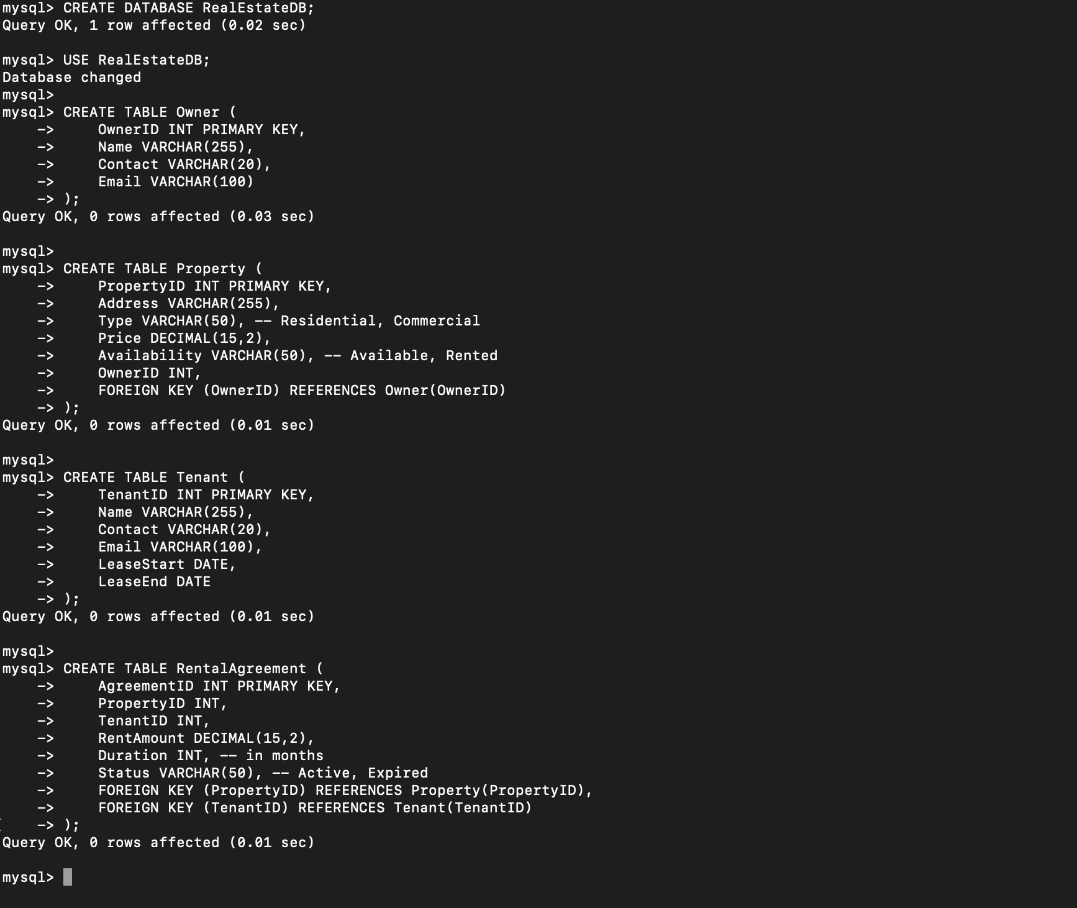

* **(b) Inserting sample data**

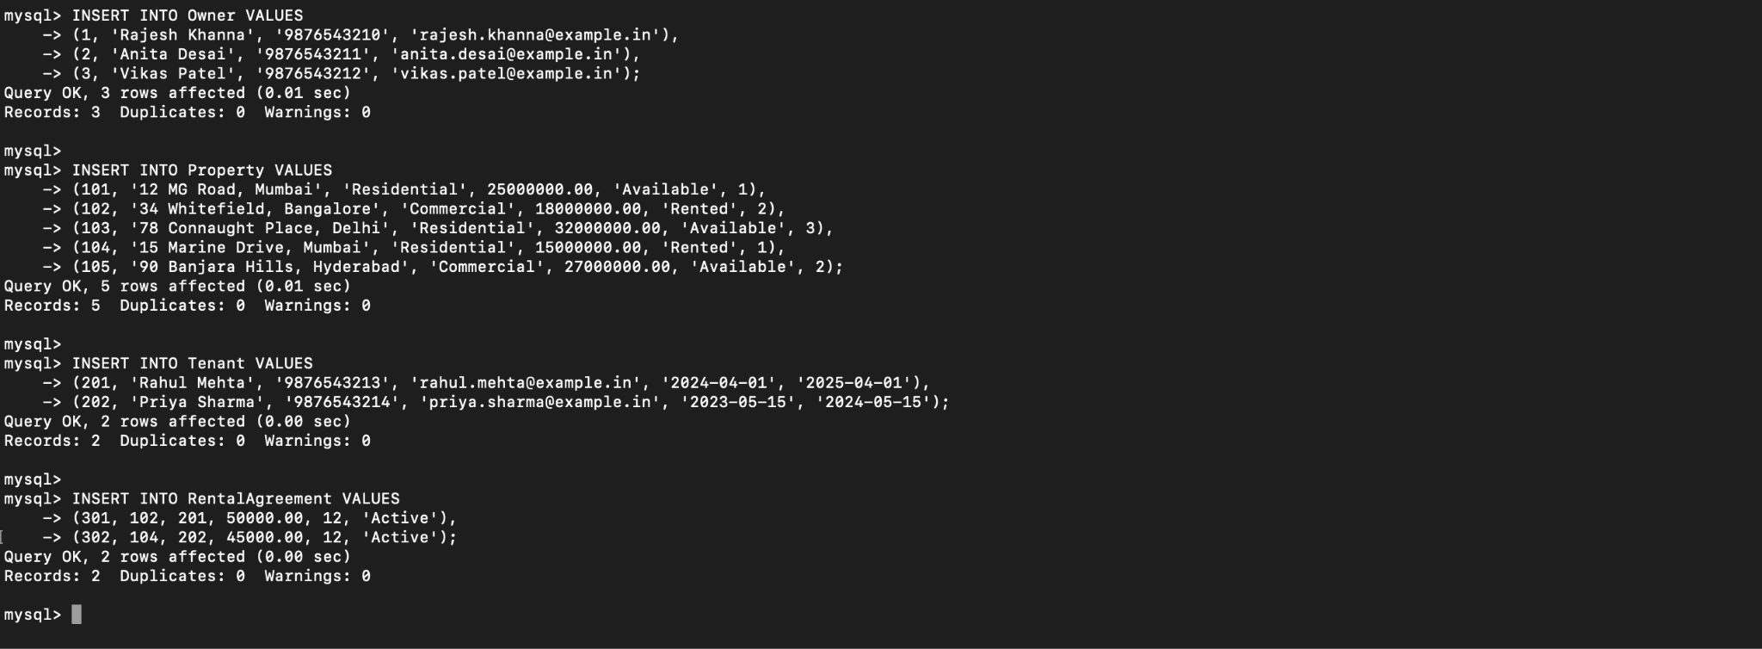

* **(c) Retrieve all available properties for rent**

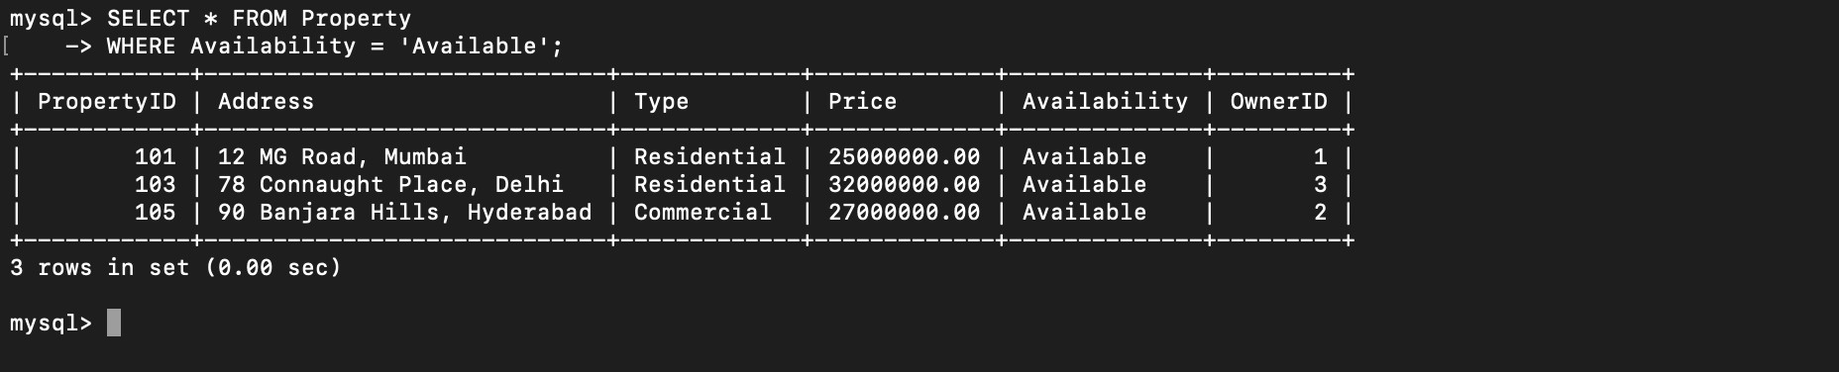

* **(d) Find tenants whose lease is expiring within the next month**

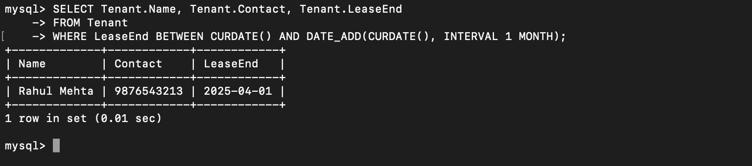

* **(e) Display the highest rental price for each property type**

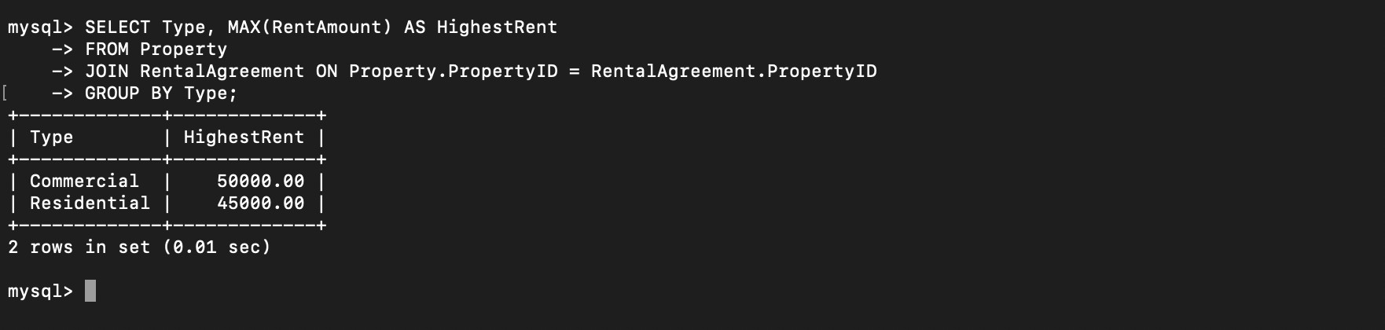

* **(f) Retrieve owners with more than 3 properties**

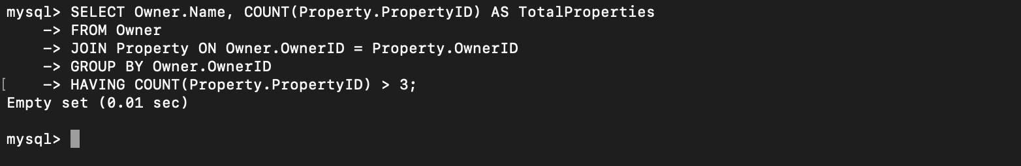

* **(g) Find the most rented property type**

